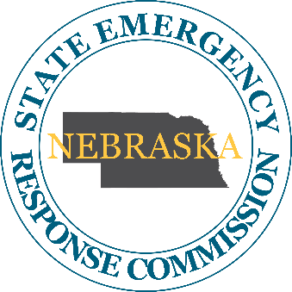
Nebraska State Emergency Response Commission

October 9th, 2025
Agenda
1:00 PM CDT
Nebraska Department of Environment and Energy
245 Fallbrook, Blvd. Hearing Room 031
Lincoln, NE 68521
Join from the meeting link
https://sonvideo.webex.com/sonvideo/j.php?MTID=m698b546a8ea502b024101f4a604f34e2

Join by meeting number
Meeting number (access code): 2495 698 9591
Meeting password: FmNpRkbE332
Tap to join from a mobile device (attendees only)
+1-408-418-9388,,24956989591## United States Toll
Join by phone
+1-408-418-9388 United States Toll
Global call-in numbers
Join from a video system or application
Dial 24956989591@sonvideo.webex.com
You can also dial 173.243.2.68 and enter your meeting number.

If you are a host, click here and login site to view host information.

Need help? Go to https://help.webex.com

-~-~-~-~-~-~-~-~-~-~-~-~-~-~-~-~-~-~-~-~-~-~-

Join by meeting number
Meeting number (access code): 2496 018 7781
Meeting password: 8t6GvxpZSt6
Tap to join from a mobile device (attendees only)
+1-408-418-9388,,24960187781## United States Toll
Join by phone
+1-408-418-9388 United States Toll
Global call-in numbers
Join from a video system or application
Dial 24960187781@sonvideo.webex.com
You can also dial 173.243.2.68 and enter your meeting number.

- Call to Order
  - This Meeting has been duly advertised, proceeded by advance notice, and is hereby declared in open session in accordance with the Nebraska Open Meetings Act, a copy is available for review in the meeting room.
  - Member Roll Call
  - Introductions

- Approval of the agenda for the October, 2025 Meeting

- Approval of the minutes from the July 2025 Meeting

- New Business
  - UP Sent the updated HHFT Information for counties affected by these trains
  - UP Railroad training
  - DHHS Lisa Osborne -Nuclear reactor power generating stations

- Member and Stakeholder Reports
  - NEMA
  - NDEE-
  - CISA Region 7
  - EPA
  - NSFM
  - NSP

Open Discussion

Speaker for next meeting is: if anyone has a suggestion please let me know so I can add them to the Agenda and contact them.

- Comments

- Adjournment

Next Meeting January 8th, 2026 Department of Water, Energy and Environment
245 Fallbrook, Blvd. Hearing Room 031, Lincoln, NE @1300

